THE GEOGRAPHY OF THE OLYMPICS 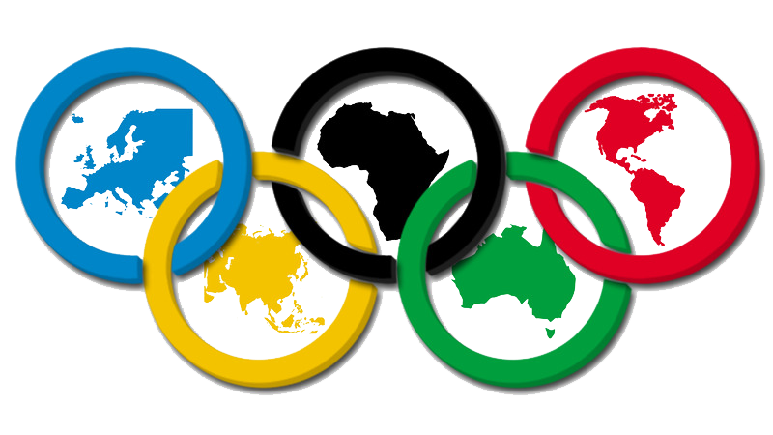

By: Charles Bowman, Tipton High School; Tipton IN, February 1992
Updated by: Robyn Simpson, Danville Community High School, 2024
Origins: Beth Steinert, Shawe Memorial High School, Madison IN, 1988

Purpose: The purpose of this lesson is to focus on a current event in which students are interested--the Winter and Summer Olympic Games. Students will plot both Summer and Winter Olympic sites since 1896 (the "where" question of geography) and will analyze the visual patterns and relationships among the mapped data (the "why" question of geography).

Teaching Levels: This lesson would be appropriate for grades 7-12.

Geographic Themes: The geographic themes emphasized in this lesson are location, place, human-environment interaction, uses of Geography

Objectives: At the conclusion of this lesson, students will have
1. plotted both Winter and Summer Olympic sites on a world map,
2. analyzed data regarding the “why of the where” the Olympics have been held,
3. analyzed the pattern created by their maps, and
4. evaluated the possibility of Indianapolis holding the Summer Olympic games in the future.

Materials Required:
- World map for each student
- Handout of The Geography of the Olympics activity for each student (or group of students)
- Student atlas for each student or each group of students/internet access for research
- Classroom atlases for more detailed analysis

Procedures:
Opening
1. Ask the students, "How many of you have watched the television coverage of the 2024 Summer Olympics?"; "Where is it being held?" "Why there?" Accept any answers at this point to encourage discussion.
2. Explain to the students about the purpose and objectives of this lesson.

Development
3. Distribute the handout to the students. They may work in small groups if they wish. Have the students use student
atlases for larger cities and more detailed atlases for smaller cities, specifically, Winter Olympic sites.
4. Upon completion of the mapping exercise, the students will answer the twelve questions and the critical thinking
scenario (which may be done for homework since the entire lesson will take 2 days).

Conclusion
5. Have a class discussion based upon the questions and the critical thinking scenario.
6. Engage the students in a class discussion about other global competitions or International Olympic Committee events with regard to the impact on humans and the environment: ParaOlympics, Esports (Saudi Arabia in 2025), Motor Sports, WWE, sanctions, economics, water and more. Research and discuss how and why Saudi Arabia can host the 2029 Asian Winter Games: engineering, construction, labor, environmental impact, human impact, innovation, technology. Compare this innovation to other societal innovations throughout history.

Evaluation: Collect the world map handouts for the purpose of grading/evaluation.

Extensions/Adaptations:
1. Have the student or groups of students research how Atlanta was able to host the 1996 Summer Olympics. Would Athens, Greece have been a sentimental favorite? Why? What advantages did Atlanta have?
2. Choose a group of students to represent the International Olympic Committee (I.O.C.). Another group of students
will be asked to represent Indianapolis, and through a simulated presentation in front of the I.O.C., the Indianapolis
representatives will have to present why Indianapolis should be the site of a Summer Olympic games. Additional
research would be necessary, so, statistics, maps, photographs ... could be used to encourage the favor of the I.O.C.
3. Use a map of Europe to plot Olympic sites on this continent alone from a historical perspective.
4. Students create story maps about Olympic sports and/or athletes (https://www.esri.com/en-us/industries/k-12-education/schools-software

Answers to the Handout
1. France, 1924; USA, 1932; Germany, 1936.
2. World War I, 1916; World War II, 1940 and 1944.
3. Europe, North America, Australia, and Asia.
4. Africa, South America, Antarctica.
5. Answers will vary, but the following are a few examples: Climate is too harsh in Antarctica (ice and bitterly cold
temperatures), much of Africa (desert and tropical conditions), regions of South America (tropical conditions);
Governments are too unstable in portions of South America and Africa, so, security might be a problem for the
athletes and officials; Developing nations could not afford to host an Olympics due to the high expense involved;
Fewer nations in Africa and South America actually participate in the Olympic games; More people and land are in
the Northern hemisphere than in the Southern hemisphere, which is less accessible.
6. Europe has a wide range of climates in a relatively small land area, a high concentration of people, and is centrally
located.
7. U.S.A. has hosted 8; France has hosted 6.
8. Only two, Australia; Fewer people live in Australia, and it is relatively isolated geographically (you
might tell students that fewer nations participated in the '56 Olympics than in 1952 due to the isolation factor); The
reverse of seasons creates a physiological problem for many athletes (The Summer Olympics were held in Nov/Dec
in 1956, which is at the beginning of the Southern hemisphere's summer; Many athletes from the Northern
hemisphere had to train differently so they could reach their peak in their winter months).
9. Only one, Mexico City. The climate is too muggy and oppressive in the tropics for athletes to compete safely. It is
interesting to note that Mexico City's high altitude (almost 8,000 feet above sea level) moderates the tropical
conditions to an extent.
10. Between 40-60 degrees north latitude; temperate climates where snow occurs in the winter is necessary.
11. Mountains (to hold outdoor events like skiing, bobsled, and luge). Specific names of landforms are: Sierra Nevada
(Squaw Valley, now renamed Olympic Valley), Rockies (Calgary), Adirondacks (Lake Placid), Alps (several sites in
Europe including the Dinaric Alps in Yugoslavia), Japanese Alps (Japan), and Kjolens (Norway).
12. Their winter is during our summer so that the athletes from the Northern hemisphere would have to be prepared to
compete at a different time of the year. Also, there is very little land in the Southern hemisphere in the middle
latitudes where conditions create snow during the winter months.

Name/Period____________________________ (student worksheet)

The Geography of the Olympics

Listed below are the city/countries where the Olympic Games have occurred since their re-introduction in 1896. On the world map provided, locate each Summer Olympic site by using a RED dot. For each Winter Olympic site by using a BLUE dot. Use available resources for location purposes: atlases, encyclopedias, library, adults, internet.

THE SUMMER OLYMPIC GAMES THE WINTER OLYMPIC GAMES

1896 Athens, Greece
1900 Paris, France
1904 St. Louis, U.S.A.
1908 London, Great Britain
1912 Stockholm, Sweden
1916 cancelled due to WWI
1920 Antwerp, Belgium
1924 Paris, France 1924 Chamonix, France
1928 Amsterdam, Netherlands 1928 St. Moritz, Switzerland
1932 Los Angeles, U.S.A. 1932 Lake Placed, New York, U.S.A.
1936 Berlin, Germany 1936 Garmisch-Partenkirchen, Germany
1940 cancelled due to WWII 1940 cancelled due to WWII
1944 cancelled due to WWII 1944 cancelled due to WWII
1948 London, Great Britain 1948 St. Moritz, Switzerland
1952 Helsinki, Finland 1952 Oslo, Norway
1956 Melbourne, Australia 1956 Cortina d’Ampezzo, Italy
1960 Rome, Italy 1960 Squaw Valley, California, U.S.A.
1964 Tokyo, Japan 1964 Innsbruck, Austria
1968 Mexico City, Mexico 1968 Grenoble, France
1972 Munich, Germany 1972 Sapporo, Japan
1976 Montreal, Canada 1976 Innsbruck, Austria
1980 Moscow, U.S.S.R. 1980 Lake Placid, New York, U.S.A.
1984 Los Angeles, U.S.A. 1984 Sarajevo, Yugoslavia
1988 Seoul, South Korea 1988 Calgary, Canada
1992 Barcelona, Spain 1992 Albertville, France
1996 Atlanta, Georgia, U.S.A. 1994 Lillehammer, Norway
2000 Sydney, Australia 1998 Nagano, Japan
2004 Athens, Greece 2002 Salt Lake City, U.S.A.
2008 Beijing, China 2006 Turin, Italy
2012 London, UK 2010 Vancouver, Canada
2016 Rio De Janeiro, Brazil 2014 Sochi, Russia
2021 Tokyo, Japan (2020 postponed due to 2018 Pyeongchang, South Korea
the COVID-19 Pandemic) 2022 Beijing, China
2024 Paris, France 2026 Milan-Cortina d’Ampezzo, Italy
2028 Los Angeles, California, U.S.A. 2030 French Alps, France
2032 Brisbane, Australia 2034 Salt Lake City, Utah, U.S.A.

Directions: Answer the following questions, on a separate piece of paper, based on the chart above and the world map that you have created.

1. In what years were both the Summer and Winter Olympics held in the same country?
Name each country and the year.

2. Why were there no Olympics held in 1916, 1940, 1944 and 2020?

3. Name the continents that have hosted the Olympic Games (either summer or winter).

4. Name the continents that have never hosted an Olympic Game (either summer or winter).

5. Speculate (give a brief list of reasons) as to why the continents in #4 have not hosted an
Olympics. State at least five (5) reasons.

6. Observe the pattern that your dots have created on the world map. Where have most of
the Olympic Games been held? Why do you think this is so?

7. What country has been the site for more Olympic Games (both summer and winter) than
any other? Which country is second? How many for each? Speculate why.

------------------------------------------------------------------------

For questions 8 and 9, observe only the Summer Olympic sites dots.

8. How many sites have hosted the Olympic Games in the Southern hemisphere? Where?
Why do you think there are so few Southern hemisphere sites?

9. How many summer Olympic sites are located within tropical regions? Where? Why are so
few held in tropical regions?

------------------------------------------------------------------------

For questions 10, 11, and 12, observe only Winter Olympic sites dots.

10. Between what degrees of latitude are Winter Olympic sites located? Why?

11. What kind of landform features are most probably near these winter sites? Using your
atlases, list the specific names of these landforms in the regions of the world where the
Winter Olympics have been held.

12. Why have no Winter Olympics been held in the Southern hemisphere?

CRITICAL THINKING SCENARIO

Assume that the International Olympic Committee is considering the city of Indianapolis to host the Summer Olympic Games in the year 2040. You are a representative of the city of Indianapolis in favor of hosting the games. Create a list of those features that a city like Indianapolis must provide to convince the Olympic Committee that Indianapolis would be the best location to host the Summer Games. The list should be extensive. A minimum of 10 items should be on your list.

Chances are, Indianapolis will not be chosen. Below, hypothesize “why” you think that the "Circle City" will not be chosen as the host-site for the 2040 Summer Olympic Games.

