How do Scientists Determine Past Climates?

What is climate? How is it different from weather? Why are people worried about climate change?

Weather deals with the atmospheric conditions in a location at a given time. Climate looks at the weather trends over a long period of time (say fifty or more years). Climate information provides a better picture of the atmospheric conditions in general. People are worried about climate change because some research suggests that the climate is changing much more rapidly than it normally would, due to human influence. This rapid change may lead to drastic effects on the environment and on human lifestyles.

In order to better understand today’s climate, scientists attempt to gain a better picture of past climates. Understanding past climates can enable us to determine whether current climate changes are normal or extreme AND whether the current climate changes will drastically impact wildlife and human lifestyles.

By understanding past climates, in combination with understanding the current climate, projections about future climates can be made through computer models/software programs. If the future climate is not favorable, humans may be able to make some lifestyle changes in order to mitigate (reduce) that we have on the climate.

Three lesson plans have been included that will enable students to better understand ways that scientists study past climates. One lesson looks at ice cores. Another lesson looks at tree-rings. And a third lesson looks at soil profiles. There are many additional methods in which scientists analyze pieces of our environment to determine past climates, but we wanted to give the students a few ideas.

Once paleoclimates are better understood, and this is on-going, current climates can be better understood, and future climates can be “managed” in terms of human contributions: pollution, development… Remember to focus on the science and human-ness of the research. Research is constant and always changes our scientific and personal perspectives. This is the constant conflict between humans and science.

Your students can pursue their areas of interest further. Many websites and books address the topic of climate change, ice cores, tree-rings, and soils. But remind them to pay attention to the authors and funders of the materials. The authors and funders have their own human agenda to fulfill utilizing science to represent their cause.

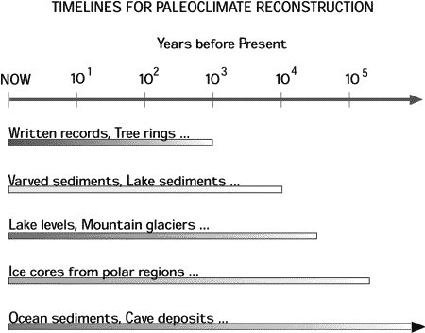

(National Ice Core Laboratory)
Tree Rings and Climate Change

Purpose: Students will analyze tree rings in order to better understand the relationship between climate and tree growth.

Grade Level(s): high school

Days/Sessions: 2-4 (if require research time)

National Geography Standards:
- How to use maps and other geographic representations, tools, and technologies to acquire, process, and report information from a spatial perspective.
- How to use mental maps to organize information about people, places, and environments in a spatial context.
- How to analyze the spatial organization of people, places and environments on Earth’s surface.
- The physical and human characteristics of places.
- That people create regions to interpret Earth’s complexity.
- The physical processes that shape the patterns of Earth’s surface.
- The characteristics and spatial distribution of ecosystems on Earth’s surface.
- How physical systems affect human systems.
- How to apply geography to interpret the past.
18. How to apply geography to interpret the present and plan for the future.

Objectives: Upon completion of the following activities, students will be able to
- identify the various components of a tree-ring and
- demonstrate an understanding of the relationship between climate and patterns of tree growth.

Materials Required
- copies of the black/white images of tree rings for each student (or small groups of students)
- projection mechanism
- If possible, Internet access to visit the various web sites mentioned throughout the activity:
  - Ultimate Tree-Ring Web Pages, web.utk.edu/~grissino/gallery.htm, by Dr. Henri Grissino-Mayer.
  - Laboratory of Tree-Ring Research, via the University of Arizona, www.ltrr.arizona.edu/treerings.html.
  - National Climatic Data Center on Paleoclimatology, www.ncdc.noaa.gov/paleo.

Key Words:
bark flood
cambium heartwood
dendrochronology sapwood
density phloem
drought

Background Knowledge: “Trees are one of nature’s most accurate timekeepers. Their growth layers, appearing as rings in the cross section of the tree trunk, record evidence of floods, droughts, insect attacks, lightning strikes, forest fires, and even earthquakes.” (from “Logs of Straw: Dendrochronology” lesson, USGS; interactive2.usgs.gov/learningweb/teachers/globalchange_time.htm).

Dendrochronology is the analysis of tree rings, including the dating of annual rings and the study of patterns of ring characteristics. These characteristics could include widths, shape, density, and composition. (NOAA National Climatic Data Center - Paleoclimatology; www.ncdc.gov/paleo). Specifically, in mid to upper latitudes, areas where there are seasons of variation in temperature and precipitation, many tree species form annual growth rings. These rings can be analyzed for various characteristics (above), and the characteristics then reveal information about local past climate. Local natural aspects that can influence the growth of a tree include soil type and depth, soil erosion, temperatures, precipitation, sun exposure, grade (angle of ground upon which the tree grew/grows), altitude, proximity to water (lakes/rivers/streams), and anything else that you can imagine that occurs in nature – similar to things that would effect the growth of plants in your yard.

Similar information about past climates can be obtained from analyzing ice cores, soil samples, and other pieces of the natural environment (cliff faces, sediment at bottom of lake beds…).

Students should be familiar with the concept of climate, with various climate types, approximate locations of climate types around the globe, and specific characteristics representative of climate type.

Procedures:
- Review the basic climate types as a class: names, locations, characteristics.
- Introduce, on the projection mechanism, image 1 through image 4 of a various tree-rings. For a color image, visit the Ultimate Tree-Ring Web Pages at web.utk.edu/~grissino/gallery.htm, where Dr. Henri Grissino-Mayer has put together a wealth of information about tree rings and analysis. Talk about the purpose of the lesson: to better understand the possibilities that tree-ring analysis offers in identifying past climates. Next, display images 5 and 6 that indicate the parts of a tree-ring. As a group identify the various components of a tree-ring and discuss.
- Also mention that scientists take tree cores (see image 7 and 8), with a small drill and about the size of a drinking straw. The cores are analyzed in a similar fashion to a tree-ring.
- Display image 9, which gives a quick visual as to “how” dendrochronologists cross-date trees based on tree-rings and tree cores.
- Discuss with the students any patterns that they may observe on the various images (previous and images 10-12).
- Discuss and highlight areas of tree growth that have a relationship to climate: heavy moisture, flood, drought, fire, lightning…
- Display a map of the United States depicting vegetation (trees/forests) from the USGS Forest Resources website (http://www.nationalatlas.gov/articles/biology/a_forest.html). Next, identify on the map the area from which the tree ring came (if information available). Conjecture about the impact of historical climate change on forestation patterns of growth and recession. Discuss the impact of humans on tree growth.
- If possible, connect to the following article via the Internet – “Predicting Abundance of 80 Tree Species Following Climate Change in the Eastern United States” by Louis R. Iverson and Anantha M. Prasad. The article is fairly technical, but it does include some map projections that give good information from which students could make inferences. http://nrs.fs.fed.us/pubs/7930. Remind the students that this research may not be agreed upon by all scientists in the field. Students are to develop their own opinion and convey that opinion via a one-two page paper. Research time may be provided.
- Conjecture about the impact that global warming could have on forest/tree growth. Think about individual trees as well as a large forest or a small (backyard) woodlet.
- Connect the local area to the discussion. Research the types of trees grown in your local community. Research the types of risks to these trees: pests, humans, weather… How can the students mitigate the impact of pests, humans, or weather/climate in order to protect, or enhance, the trees in the community? What types of resources does the local community have to assist in this effort? Encourage the students to take action of some type – written/visual advertisements, field work…

Assessment/Evaluation:
- Assess the students’ written analysis of the tree ring based on the following: five-paragraph (minimum of five sentences to each paragraph, 1” margins, 11 point font Times New Roman, single spaced) summation. The first paragraph will introduce the tree ring; the second paragraph will highlight the ring patterns; the third paragraph will highlight significant features or patterns in the tree ring; and the fifth paragraph will summarize the research.

Adaptations/Extensions:
- Proceed from this activity to the USGS Learning Web activity, “Logs of Straw: Dendrochronology”, where students will create a tree-rings from straw. See web address in Resources below.
- Contact a lumberyard to obtain several samples of tree-rings from your state or local area.
- Visit the Ultimate Tree-Ring Web Pages below to view the many photographs of trees, tree-rings, and other images.

Resources:
- Laboratory of Tree-Ring Research, via the University of Arizona, www.ltrr.arizona.edu/treerings.html.
- National Climatic Data Center on Paleoclimatology, www.ncdc.noaa.gov/paleo.
- Ultimate Tree-Ring Web Pages, web.utk.edu/~grissino/gallery.htm, by Dr. Henri Grissino-Mayer.
- Real Trees 4 Kids web site has great/easy explanations, images, and activities by grade levels. http://www.realtrees4kids.org/sixeight/stemsrings.htm (from The National Christmas Tree Association).
- USGS Learning Web, lesson plan addressing “Time and Cycles”, “Logs of Straw: Dendrochronology), http://interactive2.usgs.gof/learningweb/teachers/globalchange_time.htm.
- “The Oak”, by Adrienne Soutter-Perrot. Story about how an oak tree grows, the value of soil and minerals, production of oxygen and more. Creative Education, 1993. ISBN 0-88682-550-4.
- Penn State has a web site dedicated to “Sustainable Forestry” with a literature list for K-12 students, lesson plans, and additional related to teaching about trees. http://sftrc.cas.psu.edu/books/library/treesy.html
- An elementary school lesson plan, “My Life as a Tree” by Judy Altheide, http://www.lessonplanspage.com/ScienceSSMyLifeAsATree-RingsBarkCambiumHeartwoodK4.htm
- Backyard Nature – Plants - http://www.backyardnature.net/botany.htm; images, explanations, and classroom/home activities.
- Farm Forest Line – Tree Growth and Wood Production from The National Christmas Tree Association; http://www.farmforestline.com.au/pages/5.7.1_treegrowth.html

All images below, except where a website is indicated, were borrowed from The Ultimate Tree Ring Web Pages Photo Gallery. Managed by Dr. Henri Grissini-Mayer. If possible, visit the web site to see the images in color and more sharply. http://web.utk.edu/~grissino/gallery.htm

Image 1
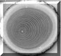

A cross section of a small red oak (Quercus rubra) that clearly shows the tree rings in both the heartwood (darker colored wood in the center) and sapwood (lighter colored wood towards the outside) (photo © H.D. Grissino-Mayer).

Image 2


Here we have a cross section from a small red pine (Pinus resinosa) that shows excellent variability in its ring widths, despite its young age (photo © H.D. Grissino-Mayer).

Image 3

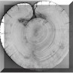

This picture shows tree rings from a fire-scarred pinyon pine (Pinus edulis) that had been growing on a southern face of a ridgetop in southeastern Colorado (photo © J. Witters). Pinyon is considered not very fire resistant and can be easily killed by wildfires, but this example shows (just like the red spruce beneath this one) that fires can affect many tree species, even those considered fire intolerant.

Image 4

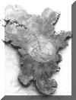

A cross section of a Rocky Mountain juniper (Juniperus scopulorum) snag (dead tree still standing) found in El Malpais National Monument near Grants, New Mexico (it's about 3 feet across) (photo © H.D. Grissino-Mayer and R.K. Adams). This tree had a pith date of 256 BC and an outer ring of about AD 1320, making this tree nearly 1,600 years old when it died!

Image 5

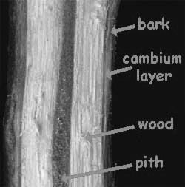

Inside woody twigs; Backyard Nature; http://www.backyardnature.net/woodtwi2.htm

Image 6
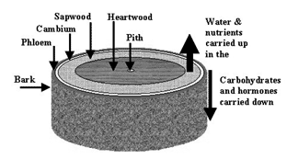
Farm Forest Line – Tree Growth and Wood Production
http://www.farmforestline.com.au/pages/5.7.1_treegrowth.html

Image 7
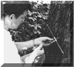 Here, a researcher is coring a tree using an increment borer (photo © Government Printing Office, Washington, D.C.). The borer itself is hollow so that a core, the width of a pencil, can be extracted from the tree.

Image 8
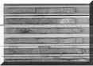
Our laboratory spends much time extracting 13 mm cores from historic structures around the Southeast. These oak (Quercus spp.) cores came from the Hoskins House in Greensboro, North Carolina, and show excellent variability in ring width that ensured successful dating (outer rings between 1811 and 1813) (photo © H.D. Grissino-Mayer).

Image 9
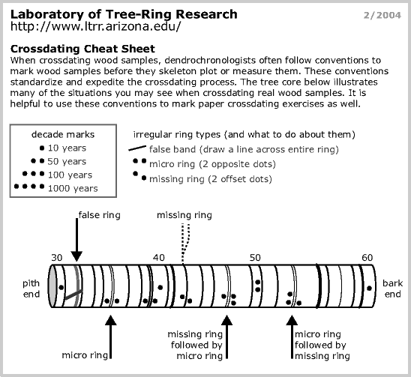

Image 10

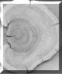 A cross section from a white spruce (Picea glauca) that was struck by a snow avalanche (impact scar on the left side of the section) in the Canadian Rocky Mountains near Alberta, Canada (photo © H.D. Grissino-Mayer and R.K. Adams).

Image 11

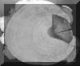

This ponderosa pine tree (Pinus ponderosa) was growing alongside a stream in Pine Canyon in the Chiricahua Mountains of southeastern Arizona (photo © H.D. Grissino-Mayer). The impact scar on the right was from a flood. Notice the resin behind the scar and how the tree leaned to its left after it was struck by the flood water.

Image 12

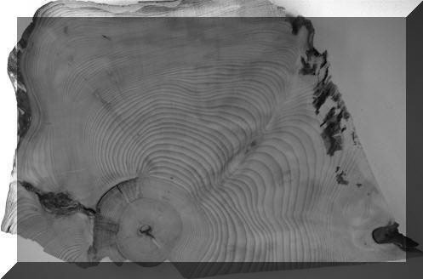

Seeing is believing. This photograph shows a fire scar on a red spruce (Picea rubens) collected from Mt. Rogers in the southern Appalachians in southern Virginia (photo © A. Krustchinsky). This must have been a low-intensity fire to have scarred the tree when it was so young, dispelling the myth that fires do not occur in such mesic, high-elevation locations of the eastern U.S.

