Remote Sensing #2: Spectral Signatures

By: Ryan Swearingen

Estimated Sessions: Second day of a two day project

Grade level: 8th Grade Social Studies and high school Geography and History of the World

Purpose: Students will learn how to navigate and interpret remote sensing and spectral signatures.

National Geography Standards addressed:
1: The use of maps and other geographical representations, tools, and technologies to acquire, process, and report
information from a spatial perspective.
18: How to apply geography to interpret the present and plan for the future.

Indiana Social Studies Academic Indicators addressed:
Eighth Grade
8.3.1 Read a topographic map to interpret its symbols. Determine the land forms and human features that represent
physical and cultural characteristics of areas in the Unites States.
    - Use of information technology, such as Geographic Information Systems and remotely sensed images to gather information on ways people have changed the physical environment of the United States in the 19th century.
High School Geography and History of the World
  - Prepare maps, timelines, and/or other graphic representations showing the origin and spread of specific
innovations. Assess the impact of these innovations on the human and physical environments of the regions to
which they spread.

Objectives: Upon completion of the activities, students will be able to
- discuss and explain the different spectral signatures for dry bare soil, vegetation, and water,
- identify and interpret color composite satellite images,
- explain reflectance values (DN values),
- identify and explain spectral signatures by reading graphs, and
- classify satellite images based on their spectral signatures.

Background:
  - Students will have already completed activities 1-3 on the interactive website.
  - Students will also be given a handout on the day before over spectral signatures. See attached.

Materials Required:
- Computer lab with internet access
- Remote Sensing and Interactive Website- http://baby.indstate.esu/mvh/
- Computers networked so that the instructor can monitor the answers
- Handout over spectral signatures, attached at the end of this lesson plan

Procedures:
- Students go to - http://baby.indstate.esu/mvh/ and log into website.
- Students will navigate through the website completing activity 4.
- Teacher will monitor the classroom and answer questions as needed.
- Discuss the impact that geo-spatial technologies has on the lives of humans and on the Earth. Identify ways in which the technologies have diffused.

Assessment:
  - Instructor will monitor the student’s answers on the interactive website.

Adaptations/Extensions/Call-Out:
- This lesson could be used in any secondary Geography class.

Resources:
- http://baby.indstate.esu/mvh/
- http://rst.gsfc.nasa.gov/

Background on Spectral Signatures
For any given material, the amount of solar radiation that is reflected (absorbed, transmitted) will vary with wavelength. This important property of matter allows us to separate distinct cover types based on their response values for a given wavelength. When we plot the response characteristics of a certain cover type against wavelength, we define what is termed the spectral signature of that cover. The diagram below illustrates the spectral signatures for some common cover types.
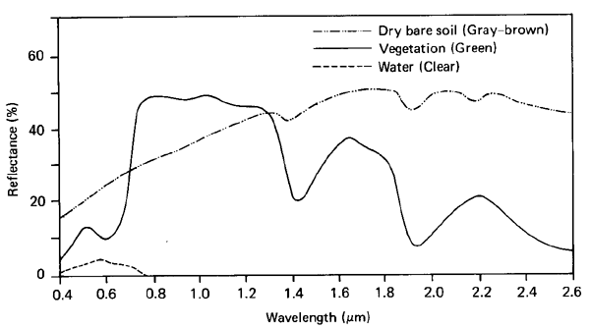
Generalized spectral signatures for some common cover types
By comparing the response patterns of different features we may be able to distinguish between them, where we might not be able to, if we only compared them at one wavelength. For example, water and vegetation may reflect somewhat similarly in the visible wavelengths but are almost always separable in the infrared. Spectral response can be quite variable, even for the same target type, and can also vary with time (e.g. "green-ness" of leaves) and location. Knowing where to "look" spectrally and understanding the factors which influence the spectral response of the features of interest are critical to correctly interpreting the interaction of electromagnetic radiation with the surface.
With a knowledge of the spectral reflectance characteristics of the earth's cover types, we can identify and map them in areas we are generally unfamiliar with. For example, you are provided with a multi-spectral image of an area in Botwsana (Africa). Even though you are totally unfamiliar with the region you can identify the dominant cover types with a high degree of certainty, by utilising known knowledge about the spectral characteristics of certain surface materials (spectral signatures).

Examples:
Water - Longer wavelength visible and near infrared radiation is absorbed more by water than shorter visible wavelengths. Thus water typically looks blue or blue-green due to stronger reflectance at these shorter wavelengths, and darker if viewed at red or near infrared wavelengths. If there is suspended sediment present in the upper layers of the water body, then this will allow better reflectivity and a brighter appearance of the water. The apparent colour of the water will show a slight shift to longer wavelengths. Suspended sediment (S) can be easily confused with shallow (but clear) water, since these two phenomena appear very similar. Chlorophyll in algae absorbs more of the blue wavelengths and reflects the green, making the water appear more green in colour when algae is present. The topography of the water surface (rough, smooth, floating materials, etc.) can also lead to complications for water-related interpretation due to potential problems of specular reflection and other influences on colour and brightness.
Vegetation - A chemical compound in leaves called chlorophyll strongly absorbs radiation in the red and blue wavelengths but reflects green wavelengths. Leaves appear "greenest" to us in the summer, when chlorophyll content is at its maximum. In autumn, there is less chlorophyll in the leaves, so there is less absorption and proportionately more reflection of the red wavelengths, making the leaves appear red or yellow (yellow is a combination of red and green wavelengths). The internal structure of healthy leaves act as excellent diffuse reflectors of near-infrared wavelengths. If our eyes were sensitive to near-infrared, trees would appear extremely bright to us at these wavelengths. In fact, measuring and monitoring the near-IR reflectance is one way that scientists can determine how healthy (or unhealthy) vegetation may be.
Soil - Soils tend to have reflection properties that increase approximately monotonically with wavelength. They tend to have high reflectance in all bands. This of course is dependant on factors such as the colour, constituents and especially the moisture content. As described above, water is a relatively strong absorber of all wavelengths, particularly those longer than the red part of the visible spectrum. Therefore, as a soils moisture content increases, the overall reflectance of that soil tends to decrease. Soils rich in iron oxide reflect proportionally more of the red than other visible wavelengths and therefore appear red (rust colour) to the human eye. A sandy soil on the other hand tends to appear bright white in imagery because visible wavelengths are more or less equally reflected, when slightly less blue wavelengths are reflected this results in a yellow colour.

