Paleo-Climatology: Analyzing Ice Cores

Purpose: In order to gain a better understanding of past climates, students will create and analyze ice cores.

Objectives: Students will be able to
- create an ice core for a particular climate zone,
- analyze an ice cores,
- translate (infer) the ice core analysis to create a mental picture of the environment at different time periods in the ice core, and
- write a summary of the change over time regarding the climate/environment that one particular ice core depicts.

Grade Level(s): adaptable from upper elementary through high school; although the lesson is written for the middle/high school levels, a simplified version could be utilized with younger students.

Sessions/Time: About four to five regular class periods.

National Geography Standards:
- How to use maps and other geographic representations, tools, and technologies to acquire, process, and report information from a spatial perspective.
3. How to analyze the spatial organization of people, places, and environments on Earth’s surface.
4. The physical and human characteristics of places.
7. The physical processes that shape the patterns of Earth’s surface.
8. The characteristics and spatial distribution of ecosystems on Earth’s surface.
17. How to apply geography to interpret the past.

Materials Required:
- ten ice-cube trays
- two 13” x 9” cake pans
- collection of detritus: soil, sand, seeds, ash, pebbles, small rocks, gravel, grass, leaves, dead bugs, twigs…
- ten pieces of aluminum paper (about 16” long x 5” wide)
- pitchers for water
- materials for clean-up (broom, dust-pan, towels)
- writing utensils (pencils/colored pencils)
- Copies for each student (or small groups of students dependent upon paper supply and needs of students) of the Project 1 and Project 2 worksheets and of the Paleo-Climatology: Ice Core Background Information sheet
- Projection mechanism

Background Knowledge:
Students must have an idea about the relationship between the Earth and the Sun, weather and climate, and biomes.

Ice cores contain an abundance of climate information --more so than any other natural recorder of climate such as tree rings or sediment layers. Although their record is short (in geologic terms), it can be highly detailed. An ice core from the right site can contain an uninterrupted, detailed climate record extending back hundreds of thousands of years. This record can include temperature, precipitation , chemistry and gas composition of the lower atmosphere, volcanic eruptions, solar variability, sea-surface productivity and a variety of other climate indicators. It is the simultaneity of these properties recorded in the ice that makes ice cores such a powerful tool in paleoclimate research. (National Ice Core Laboratories web site. THANKS to Eric Cravens, Assistant Curator!)

Pre-activity work by the teacher: Educator must accumulate the materials for the project, must secure freezer space, and must arrange for a mechanism to display any images to the class.
Key Words:
analyze detritus (this is fun word that most students enjoy)
biome infer
climate paleo-climatology
depict

Procedures:
Day 1
- Review the concepts of biomes and climate zones with the students. Discuss the relationship between the two, the types of plant and animal life, and human lifestyles.
- Display a World Climate Zones map. Briefly discuss the map information and relate it to the previous discussion.
- Distribute and read “Paleo-Climatology: Ice Core Background Information “.
- Display the Global Average Temperature Shift in Relation to Geologic Time image. Discuss the information in the image. Discuss the information and its relationship to historic climate and climate change. If possible, visit the PALEOMAP web site mentioned in Resources section.
- Display the three ice core profiles from the Greenland Ice Sheet Project hand-out or visit the NICL web site to see the images in color. Discuss any interesting observations that the students may have. Make the connection between past climates and deposits (or findings) in ice cores focusing on the various items found in ice cores as examples (see the Various Items Measured sheet).
- Go outside to collect small natural materials that may be utilized in the classroom-made ice cores (see the materials list above).
Day 2
- Divide the students into small groups of 2-3.
- Give each group: copy of Project 1 worksheet (Paleo-Climatology: Ice Core Profile Creation), writing utensil(s), one ice-cube tray, a pitcher of water, and their natural materials.
- Tell the students that they will be creating ice cores that must convey a real-life possibility, which will be analyzed by another group of students.
- Each group will think about and discuss possible ice core scenarios, utilizing the paper and pencil/colored pencils to draw a rough sketch. Students will complete the information on the Project 1 worksheet. Students will create a sketch of possible ice core on the bottom space of the Project 1 worksheet. Once the students are satisfied with their sketch, they will create the ice core using the ice cube trays, water, and the natural materials (sand, leaves…).
- CAUTION students to think about the ice core as a continuous column, so, that they must think about how they will layer the ice cubes to create the column – once the ice cubes are frozen solid. Each cube in the tray must be a portion of the ice core column. Each cube will convey a historically accurate possibility: some may be plain water, some may contain a small amount of sand, some may contain only soil, some may contain gravel, some may contain a variety of materials – bark, dead bugs, leaves, soil…
- Once the students have created their ice core profile via the ice cube trays, freeze the materials. Make sure to mark each tray by group.
Day 3
- The next available class period, after the ice cube trays are completely frozen, have the students reconvene in their small groups. Give each group their ice cube tray and a sheet of aluminum foil (or other appropriate material).
- The groups will arrange their ice cubes into a column in the foil (lengthwise), based upon their original ice core sketch/plan from the Project 1 worksheet. The ice cubes should be touching end-to-end. The columns (in the foil) will be placed into the cake pan, with the foil separating each column to prevent contact with other columns AND to maintain contact among the ice cubes within a column.
- Place the pans, with columns, into the freezer. Place the cubes close together so that they fuse together. The idea is to create a continuous “column” of ice.
Days 4-5
- The next class period, take the frozen columns out of the freezer. Again, divide the students into their working groups. Each group is to receive a column (NOT the one that they created). Also, the groups will need a copy of the Project 2 worksheet (Paleo-Climatology: Ice Core Profile Analysis) and writing utensils (pencil/colored pencils).
- First, the group will complete the information at the top of the Project 2 worksheet. The group will create an ice core sketch of their column. And the group will write a two-four page analysis of the ice core noting physical characteristics, plausible biomes/environmental factors (climate, animal and plant life, human impact). The written analysis MUST have input from all group members, must be logical (appropriate connections to realistic possibilities), and must begin with analysis from either the surface down OR the bottom to the surface (not starting in the middle).
- Students will be given the class period to develop the sketch and begin the written analysis. Another class period will be given for further development and completion of the written analysis. Or this may be given as a homework assignment. The written analysis must be typed, .5” margins top/bottom, .8” margins right/left, 1.5 line spacing, 11 point font Times New Roman (or similar font) –in other words, no large margins, no large line spacing, and no large fonts to take the place of content!!!! For younger students, a cursive/printed analysis would be fine. Each student in the group could take a section of the column to complete the written analysis. Focus on team-work in development and analysis.
- Make sure to recycle the aluminum foil!

Assessment(s):
- Group interaction and contribution to team efforts. (group)
- Group creation of an ice core – end product Project 1 worksheet. (group)
- Written summary of the analysis of one ice core - Project 2 worksheet and summary. (group)

Adaptations/Extensions:
- If possible, take digital images of each phase of the process. Students then create a Power Point presentation of the columns with accompanying written analysis. Post the Power Point for other students/classes/parents to view.
- Invite a climatologist (meteorologist) to visit the classroom to discuss weather, climate, and past climates. Make sure that the guest is comfortable with discussing past climates. Share the ice core profiles with the guest and discuss. Each state has a “state climatologist” and many post-secondary institutions (especially those with any type of program in agriculture, meteorology, atmospheric studies, energy studies) have climatologists and/or paleo-climatologists.

Resources: Lots of resources are available, much of them are technical. A few are more “non expert” oriented. Several resource web site have interesting images, but they are in Danish, Japanese, or German.
  - National Ice Core Laboratories - Contact us by email: nicl@usgs.gov or by phone: (303) 202-4830. Or by web at http://nicl.usgs.gov/index.html. If you live in the Denver, Colorado area, home to the NICL, you can arrange a visit.
  - National Snow and Ice Data Center - http://www-nsidc.colorado.edu/
  - The World Data Centers Ice Core Gateway provides a single portal to the ice core data archives of the NOAA Paleoclimatology Program, World Data Center for Paleoclimatology, National Snow and Ice Data Center, and World Data Center for Glaciology. http://www.ncdc.noaa.gov/paleo/icgate.html
  - British Antarctic Survey – article addressing the discovery of the value of ice cores, scientific information gained from ice cores, and the logistics of ice core drilling. http://www.antarctica.ac.uk/indepth/icecore/page1.php
  - Related links to ice, snow, glacier, tundra, alpine, and other cold-region web sites is provided by the NICL. http://nicl.usgs.gov/links.htm
  - A tundra-cam is available for an alpine site outside of Denver, Colorado, but you have to have the correct JAVA script. Students can study a particular site in the camera’s viewing range and take a photograph. A gallery of images is available if you cannot utilize the camera. Not necessarily ice core related, but interesting. http://instaar.colorado.edu/tundracam/index.php
  - Blue Planet has a nice web site addressing world biomes with easy descriptions and nice images: http://www.blueplanetbiomes.org/climate.htm
  - An animation that depicts the changing climatic belt; by Christopher Scotese. Requires a JAVA applet. http://www.scotese.com/paleocli.htm. And a PALEOMAP site developed by Mr. Scotese making available animations of climate change over geologic time available, http://www.scotese.com/
  - The National Geophysical Data Center Paleoclimatology Program has information available about climates, past, present and future: brief explanations and animations. http://www.ngdc.noaa.gov/paleo/ctl/landuse.html
Project 1 Paleo-Climatology: Ice Core Profile Creation

Date:

Time:

Group Members:

Project 2 Paleo-Climatology: Ice Core Profile Analysis

Date:

Time:

Group Members:

Paleo-Climatology – Ice Core Background Information
(taken directly from National Ice Core Laboratory web site)

Why Study Ice Cores? Ice cores contain an abundance of climate information --more so than any other natural recorder of climate such as tree rings or sediment layers. Although their record is short (in geologic terms), it can be highly detailed. An ice core from the right site can contain an uninterrupted, detailed climate record extending back hundreds of thousands of years. This record can include temperature, precipitation , chemistry and gas composition of the lower atmosphere, volcanic eruptions, solar variability, sea-surface productivity and a variety of other climate indicators. It is the simultaneity of these properties recorded in the ice that makes ice cores such a powerful tool in paleoclimate research.

Climatology, the study of how the Earth's climate system works, operates under a distinct handicap in comparison to other phenomenological sciences. Other fields of study permit the formation of hypotheses and subsequent testing of these hypotheses by direct experimentation in the laboratory. This is not feasible in climatology, for we live in the only laboratory possible. It is called the Earth.

Because we would be ill-advised to experiment on our only laboratory, we are left to construct computer models of how we believe the climate system of our planet works. If we understand the climate system correctly and have constructed our model appropriately, then the behavior of our model climate system should mimic the behavior of the Earth's climate system. One of the best ways to test our model is to see if it can reproduce the changes in climate which have happened throughout the long history of the Earth. Thus, acquiring detailed climate records extending back many hundreds of thousands of years has become a research priority in the study of global change.

The study of ice cores is an indispensible part of this process. Over the past decade, research on the climate record frozen in ice cores from the polar regions has changed our basic understanding of how the climate system works. Changes in temperature and precipitation which previously we believed would require many thousands of years to happen were revealed, through the study of ice cores, to have happened in fewer than twenty years. These discoveries have challenged our beliefs about how the climate system works. We have been required to search for new, faster mechanisms for climate change and we have begun to consider the interaction between industrial man and climate in light of these newly revealed mechanisms.

How are Ice Cores Transported? Acquiring each ice core from a remote region of the world and transporting it back to the National Ice Core Laboratory safely can require several years of planning and execution. Drilling the core is the responsibility of the Ice Coring and Drilling Services. The process of safely transporting ice cores from the drill site back to the National Ice Core Laboratory in Denver requires the diligence and cooperation of several organizations including the National Science Foundation, Raytheon Polar Services and the New York Air National Guard. Flying the ice core from the site to a coastal location where the ice core is, then, transported via ship to the United States takes precise planning and secured funding. The correct equipment in the transportation process must be available, too. There are guidelines and policies that must be followed in order to ensure the appropriate acquisition of an ice core, the safe transportation of the ice core, and the adequate storage of the ice core for scientific study.

Who Warehouses the Ice Cores? The U.S. National Ice Core Laboratory (NICL) is a facility for storing, curating, and studying ice cores recovered from the polar regions of the world. It provides scientists with the capability to conduct examinations and measurements on ice cores, and it preserves the integrity of these ice cores in a long-term repository for current and future investigations.

Greenland Ice Sheet Project – background information to share with students

On 1 July 1993 the Greenland Ice Sheet Project Two (GISP2) successfully completed drilling through the base of the Greenland Ice Sheet and another 1.55m into bedrock at a site in the Summit region of central Greenland (72º 36' N, 38º 30' W; 3200 masl) (Mayewski et al., 1994a). In so doing GISP2 recovered the deepest ice core record in the northern hemisphere (3053.44 meters). The Greenland Ice Core Project (GRIP), GISP2's European companion (30km to the east of GISP2 site) penetrated the ice sheet to a depth of 3028.8m one year earlier. Between these two projects, the longest (ice core) paleo-environmental record (>100,000 years) ever compiled is now available for the Northern Hemisphere.

The following images and information can be found at the National Ice Core Laboratories (NICL) web site,
http://nicl.usgs.gov/zimages.htm. The images via the web site contain lots of bytes and take time to download, but if you “save” the images, this takes much less time. In color, the surface and middle level images are similar to the black/white versions below, but the base image is very dramatic as it is coppery browns, which include soil/silt, pebbles, and more – which would indicate the interaction between the ice sheet and the ground.



Surface of the Greenland Ice Sheet: GISP2D 54 is from the Greenland Ice Sheet. This core is actually firn (the packed version of snow) and not ice. Top Depth is 53.00 meters deep. Bottom Depth 54.00 meters below surface. There is some light banding visible, but due to the properties of firn, they are not that distinct. At a depth of 54.16 meters below surface the age is 104 years before present or 1846 AD.

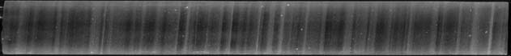

Mid-Section of the Greenland Ice Sheet: GISP2D 1837 is from the Greenland Ice sheet. Top depth is 1836.00 meters deep. Bottom depth is 1837.00 meters below surface. Banding (annual layers) is very distinct. The appearance of layers results from differences in the size of snow crystals deposited in winter versus summer and resulting variations in the abundance and size of air bubbles trapped in the ice. Counting such layers has been used (in combination with other techniques) to reliably determine the age of the ice (Meese et al. 1997). The dark areas indicate time periods when little to no sublimation (or settling of particles) occurred – winter. The cloudy areas indicate time periods when little to lots of sublimation occurred – summer, warmer temperatures, with lots of particles settling onto the surface. At a depth of 1837 meters below surface the age is 16,198 years before present (1950) or 14,248 BC.

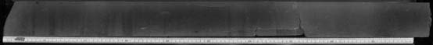

Base of the Greenland Ice Sheet: GISP2D 3051 is from the Greenland Ice sheet. Top depth is 3050.00 meters. Bottom depth is 3051.00 meters below surface. This is ice at the base of the glacier and will include bits of dirt, small pebbles, and clay pockets. There is some banding visible. The image in color is shades of coppery brown. Visit the National Ice Core Lab web site to see the color image. http://nicl.usgs.gov/zimages.htm

Various Items Measured in an Ice Core: http://nicl.usgs.gov/why.htm


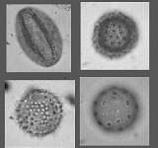

Pollen grains which are washed or blown into lakes can accumulate in sediments and provide a record of past vegetation. Different types of pollen in lake sediments reflect the vegetation that was present around the lake, and therefore the climate conditions favorable for that vegetation. The NOAA Paleoclimatology Program distributes the product of various collaborative efforts to collect and organize pollen records from around the globe. http://www.ncdc.noaa.gov/paleo/pollen.html



Gas particles (air bubbles)
(*NICL)


Lots of air bubbles seen in a slice taken from an ice core from the Antarctic. British Antarctic Survey, photograph in an article entitled “The Ice Man Cometh”, http://www.antarctica.ac.uk/indepth/icecore/page1.php

Precipitation
Snow crystal images borrowed from Kenneth G. Libbrecht, Caltech, SnowCrystals.com =
http://www.its.caltech.edu/~atomic/snowcrystals/ (a beautiful collection of snow crystal images).

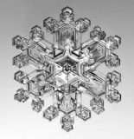

Chemistry
Analysis of e.g. oxygen isotopes and chemical profiling provides information of temperature variations and atmospheric conditions. For example, sea salts, industrial heavy metal emissions, atmospheric terrestrial dust, and marine and terrestrial biogenic emissions. From the web site highlighting the Norwegian-U.S. Scientific Traverse of East Antarctica, http://traverse.npolar.no/.

top depth (m) bottom depth (m) Cl NO3 SO4 NA

18.01 18.04 70.4 35.2 48.6 32
18.04 18.07 50.3 37.4 94.3 23.5
18.07 18.07 62.9 4.62
.
.
.
95.46 95.49 56.9 12.4 71 4.48
95.49 95.52 65.3 11.2 119 16.41
95.52 95.55 63.7 10.4 88 5.61
95.55 95.58 63.9 11.7 134 15.52



Volcanic eruptions
(*NICL)
See the darker gray line in the ice core. Electrical properties allow
detection of volcanic ash layers in the ice cores.

*NICL © Copyright
These images were produced at the National Ice Core Laboratory.
A Brief Photo Collection of Ice Core Activities: *NICL © Copyright
These images were produced at the National Ice Core Laboratory.

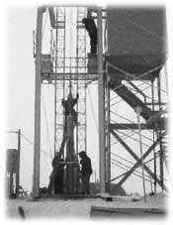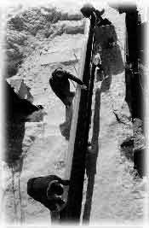
Large, highly specialized equipment is utilized to drill ice cores. Ice cores can be one meter in length (easiest, cheapest, and most common), and the longest was a little over 3,600 meters from a site in Vostok, Antarctica.

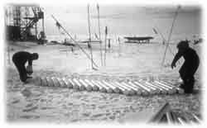
Team members hurry to prepare the one meter ice cores for transportation via airplane. The cores are stored in an underground vault until this time.

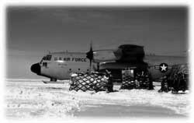
A specially equipped transport airplane from the U.S. Air Force hauls insulated materials on large pallets to and from the various ice core research sites.

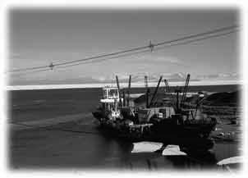
Once the ice cores reach a coastal facility, they are transferred from the airplane to a refrigerated ship to be brought to the United States. From a U.S. harbor, the ice cores are transported to the National Ice Core Laboratories in various ways: air, truck, rail.

The ice cores are very carefully handled at the NICL.

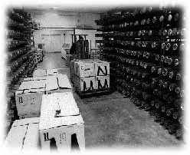
When a shipment of new ice arrives, the insulated boxes carrying the cores are quickly unloaded into the main storage area at the lab. This part of the lab is held at -35 degrees Celsius to promote the longevity of the cores and to minimize sublimation and diffusion.

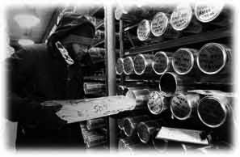


You can plan a visit to the National Ice Core Laboratory in Denver, Colorado. But wear a heavy coat and warm mittens!

Global Average Temperate Shifts in Relation to Geologic Time

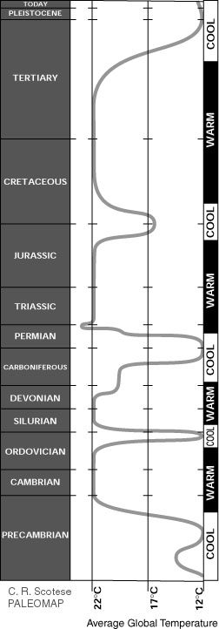
Christopher R. Scotese with the PALEOMAP Project prepared this image from lots of consolidated data and research. The image depicts global average temperature shifts in relation to geologic time. For an animated tour of climate change over geologic time, visit the PALEOMAP web site at http://www.scotese.com/

