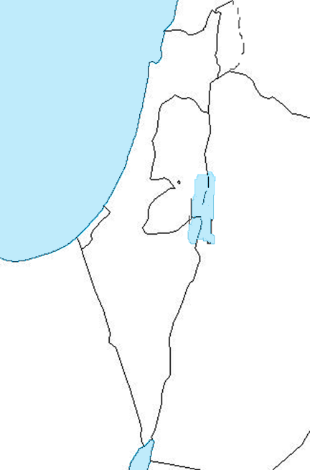

MAP OF ISRAEL

Name________________________________Due Date__________Class Period_________

